Inspection Date | 16/3/2023 | Report Ref. No. | MACINS066 16/3/2023
Site Name |  | Location | Lab L00020
Inspected By | Hend Al Zaabi | Witnessed by

Inspection Type | ✓ General ✓ Housekeeping & Sanitation ✓ Fire ✓ Electrical ◻ Ladders ✓ Lab ◻Food ◻ Structure ◻ Motor Vehicles ◻Landscaping ✓ PPE ◻ Stores ◻ Emergency Evacuation

Findings
 | ☑ Safety ☑ Environment ◻ Occupational health
S/N | Description | Significant Risk  Yes/No | Risk Evaluation
S/N | Description | Significant Risk  Yes/No | Low | Med | High
 | Equipment’s found without fluorescent barrier tapes on floors around the equipment. | Yes
 | Un-approved power extension cord used in the lab | Yes
 | Power cut-off switch and electrical panel for lab found hindered | Yes
 | False Ceiling tile not fixed properly | No
 | Trip hazard observe in the lab | Yes
 | First aider poster details not updated in the lab | Yes
 | Poor housekeeping | Yes

Attachment | ◻ Photos ◻ Video Footage ◻ Other

Corrective actions
S/N | Description
 | Short Term Action |  |  | Long Term Action |  | By Whom |  |  |  |  | By When
 | Barricading to be provided for the equipment |  |  |  |  | Lab in charge/FM |  |  |  | 23/4/2023
 | Approved extension need to be used in the lab. |  |  |  |  | Lab in charge/FM |  |  |  | 23/4/2023
 | Power cut-off switch access need to be clear |  |  |  |  | Lab in charge/FM |  |  |  | 23/4/2023
 | False Ceiling tile need to be fixed properly |  |  |  |  | Lab in charge/FM |  |  |  | 23/4/2023
 | Cable management need to be done |  |  |  |  | Lab in charge/FM |  |  |  | 23/4/2023
 | First aider poster details need to be updated |  |  |  |  | Lab in charge/FM |  |  |  | 23/4/2023
 | Housekeeping need to be done |  |  |  |  | Lab in charge/FM |  |  |  | 23/4/2023
Prepared by: ESH Section |  |  |  | Received by: |  |  |  | Followed up by:
 |  |  |  | Contractor: | Consultant: |  |  |  | ◻ Corrective Action is taken |  |  |  | ◻ Corrective action not taken
Name |  | Hend Alzaabi | Name |  |  |  | Name |  |  |  |  | Name
Designation |  |  | Designation |  |  |  | Designation |  |  |  |  | Designation
Signature |  |  | Signature |  |  |  | Signature |  |  |  |  | Signature
Date |  |  | Date |  |  |  | Date |  |  |  |  | Date

Attached Photos
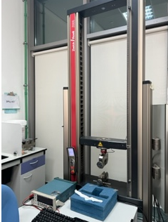  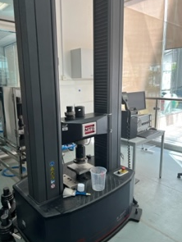 | 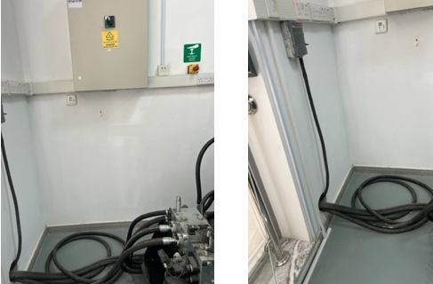
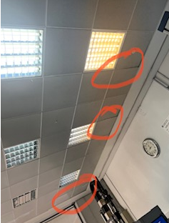 | 